RTL Circuits: NOR GATE
Overview:
This invertor circuit takes two inputs of either a “HIGH” or “LOW” signal. Dependant on the combination of inputs, the combined signal will be inverted and either illuminate or turn off the LED. The logic circuit is constructed using a combination of transistors and resistors.

Equipment:
- 2× 10kΩ and 1× 1kΩ resistor
- 2× 2N3904 BJTs
- LED
- 5V Linear Breadboard Supply (details in README)

Schematic:
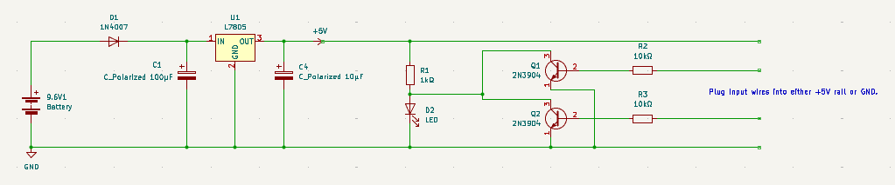
Figure 1: NAND Gate circuit connected to linear power supply

Truth Table:

Input (X) | Input (Y) | Output (Z)
0 | 0 | 1
0 | 1 | 0
1 | 0 | 0
1 | 1 | 0

Circuit Operation
The floating wire inputs connected to the bases of the 2N3904 BJTs can be connected alternately between the +5V rail (logic “HIGH”, “1”) and GND (logic “ZERO”, “0”).
Theoretically, when our combination of input logic is:
- Q1 – Logic 0, Q2 – Logic 0
Both BJTs are switched off and in cut-off operation as the voltage across the base-emitter junction is essentially 0. The BJTs act as open switches, hence the LED is ON.
- Q1 – Logic 0, Q2 – Logic 1
The top transistor (Q1) stays in cut-off and acts as an open switch. The bottom transistor (Q2) behaves as a closed switch as the 5V input provides sufficient base current. This input voltage overcomes the 0.7V base-emitter junction barrier, driving the transistor into saturation. This forms a much lower resistance pathway to GND than the LED, so the main supply current is diverted through Q2, hence the LED is OFF.
- Q1 – Logic 1, Q2 – Logic 0
The bottom transistor (Q2) stays in cut-off and acts as an open switch. The top transistor (Q1) behaves as a closed switch as the 5V input provides sufficient base current. This input voltage overcomes the 0.7V base-emitter junction barrier, driving the transistor into saturation. This forms a much lower resistance pathway to GND than the LED, so the main supply current is diverted through Q2, hence the LED is OFF.
- Q1 – Logic 1, Q2 – Logic 1
Both BJTs receive sufficient base current and are driven into saturation. Together, they form a continuous, low-resistance path to GND. This branch effectively acts as a short circuit, starving the parallel LED branch of current and pulling the output node LOW, so the LED is OFF.

Experimental Calculations
Scenario | $$V_{CE }/ V$$
1 | 2.5
2 | 0.0088
3 | 0.0109
4 | 0.0083

In states where output logic is LOW, measured voltages are significantly lower than standard saturation voltages across the collector-emitter junction (0.2V) [1].
For deep saturation, the maximum load current is required. We can use the equation $I_{C}=\frac{V_{CC}-V_{CE}}{R_{C}}$. Hence, we can approximate the collector current to be 4.99mA.
The base current can be given as $I_{B}=\frac{V_{CC}-V_{BE}}{R_{B}}$. As our standard base-emitter voltage is given as 0.7V, we can calculate the base current as 0.43mA.
Our forced beta ($β_{forced}$) can be defined as the collector current divided by our base current, which gives 11.6, which is significantly lower than a standard DC Current Gain for a 2N3904 BJT at 150 [1]. This shows that there is too much base current compared to the collector current, forcing it into deep saturation, so the transistor acts as almost ideal switch.

References
[1] ‘2N3903 - General Purpose Transistors’. Accessed: Jul. 11, 2026. [Online]. Available: https://www.onsemi.com/download/data-sheet/pdf/2n3903-d.pdf

